Key points for students
Some useful scratch features for creating the app.
To create a variable to save the score select make a variable and give it a name:
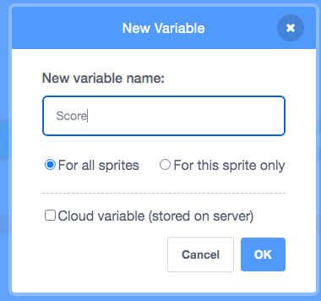
You can set the new variable to zero or add 1 to the variable with the blocks:
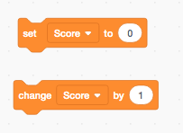
To create a new sprite, select the option at the bottom left of the sprite area and choose paint. This will allow you to create a new sprite to use in your app:
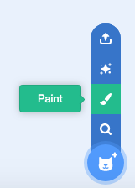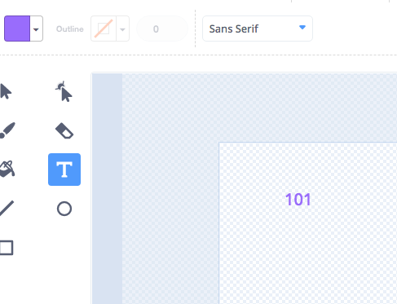

To check if a sprite has been clicked on you will need to use a script that starts with this control block:
